**GIGACLEAR PROGRAMMING CHALLENGE**

**Context:**

Gigaclear are all about putting cables in the ground. To stay on top of our finances, we need to understand how much it costs to get our cables to a given number of premises (referred to as “pots”). For this exercise, assume that each pot is linked to a central cabinet via a cable buried in trenches (in the road or verge) and buried chambers. An example network might look like this:

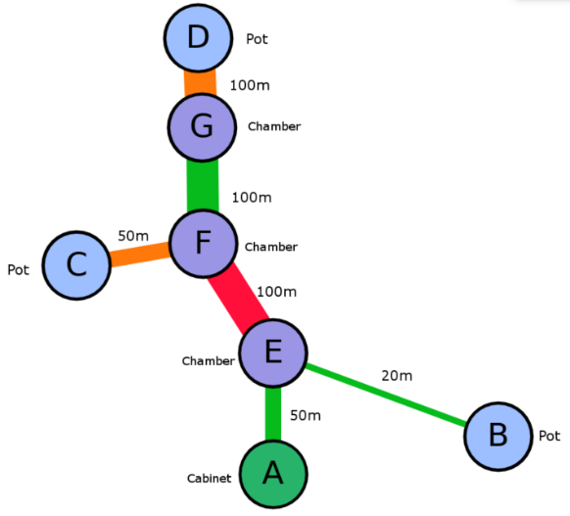

And be represented by the format on the next page.

The cost of a build is calculated according to a series of “Rate Cards” agreed between Gigaclear and the contractors that physically build our network. Two example rate cards are as follows:

|  |  |  |  |  |
| --- | --- | --- | --- | --- |
| **Rate Card A** | |  | **Rate Card B** | |
| **Item** | **Cost (£)** |  | **Item** | **Cost (£)** |
| Cabinet | 1000 |  | Cabinet | 1200 |
| Trench/m (verge) | 50 |  | Trench/m (verge) | 40 |
| Trench/m (road) | 100 |  | Trench/m (road) | 80 |
| Chamber | 200 |  | Chamber | 200 |
| Pot | 100 |  | Pot | 20 x trench length  (in meters) from Cabinet |

A single pot connected to a cabinet via 10m of cable in verge and one chamber would cost £1,800 costed using Rate Card A, or £2,000 using Rate Card B.

**Question:**

Create a program that will output the correct costs for the network above – and any other provided in the same format – using both Rate Cards shown above.

**Rules:**

You can use the language of your choice to solve this.

Please do not spend more than two or three hours on this exercise and feel free to submit your work even if you have not fully solved the problem – we just want to see how your mind works when approaching the problem.

You are free to use the internet and any resources available to you.

Please demonstrate production-quality coding practices as applicable.

Please be prepared to talk through your solution at the interview.

<?xml version='1.0' encoding='utf-8'?>

<graphml xmlns="http://graphml.graphdrawing.org/xmlns" xmlns:xsi="http://www.w3.org/2001/XMLSchema-instance" xsi:schemaLocation="http://graphml.graphdrawing.org/xmlns http://graphml.graphdrawing.org/xmlns/1.0/graphml.xsd">

<key attr.name="weight" attr.type="long" for="edge" id="d2" />

<key attr.name="material" attr.type="string" for="edge" id="d1" />

<key attr.name="type" attr.type="string" for="node" id="d0" />

<graph edgedefault="undirected">

<node id="A">

<data key="d0">Cabinet</data>

</node>

<node id="B">

<data key="d0">Pot</data>

</node>

<node id="C">

<data key="d0">Pot</data>

</node>

<node id="D">

<data key="d0">Pot</data>

</node>

<node id="E">

<data key="d0">Chamber</data>

</node>

<node id="F">

<data key="d0">Chamber</data>

</node>

<node id="G">

<data key="d0">Chamber</data>

</node>

<edge source="A" target="E">

<data key="d1">verge</data>

<data key="d2">50</data>

</edge>

<edge source="B" target="E">

<data key="d1">verge</data>

<data key="d2">20</data>

</edge>

<edge source="C" target="F">

<data key="d1">footway</data>

<data key="d2">50</data>

</edge>

<edge source="D" target="G">

<data key="d1">footway</data>

<data key="d2">100</data>

</edge>

<edge source="E" target="F">

<data key="d1">carriageway</data>

<data key="d2">100</data>

</edge>

<edge source="F" target="G">

<data key="d1">verge</data>

<data key="d2">100</data>

</edge>

</graph>

</graphml>